nest巢 newspaper报纸 nose鼻子

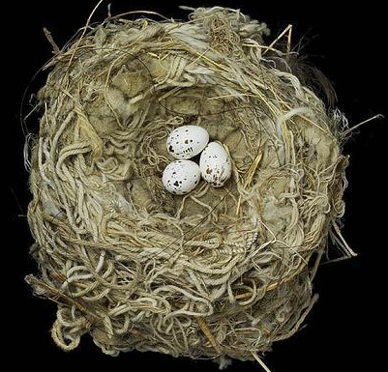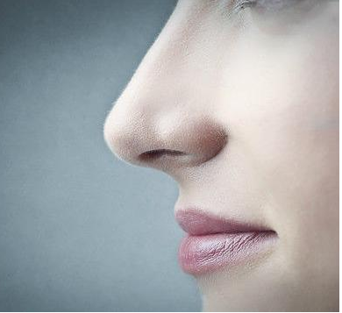

nine九 neck脖子 net网
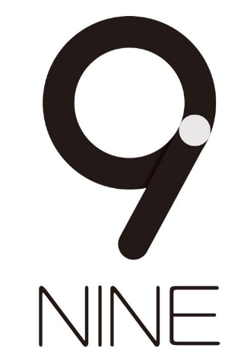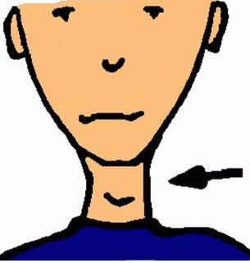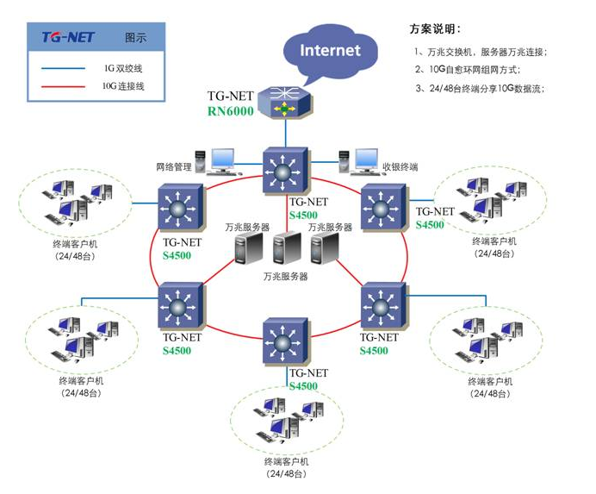

1、What＇s this letter?
It's letter Nn.


2.Which word begins with letter Nn?
Nine begins with letter Nn.

3、What sound does Nn make?
Nn makes sound /n/.

